FILE TRANFER USING CRYPTOGRAPHIC TECHNIQUE
BY

PAPPU KUMAR (13QH1A0537)
NUSRAT JAMAL (13QH1A0533)
SUMIT KUMAR (13QH1A0561)
SHIV KUMAR (13QH1A0550)

Guide:
Mr. Abdul Kalam
Associate professor



DEPARTMENT OF COMPUTER SCIENCE AND ENGINEERING
HOLY MARY INSTITUTE OF TECHNOLOGY
(Approved by AICTE, New Delhi, Affiliated to JNTUH)
Bogaram (V), Keesara (M), R.R (DIST) 501301

2016-2017
FILE TRANSFER USING CRYPTOGRAPHIC TECHNIQUE
A Major project report
Submitted in fulfillment of the requirements

For the award of degree of

BACHELOR OF TECHNOLOGY
IN
COMPUTER SCIENCE AND ENGINEERING

BY
PAPPU KUMAR (13QH1A0537)
NUSRAT JAMAL (13QH1A0533)
SUMIT KUMAR (13QH1A0561)
SHIV KUMAR (13QH1A0550)

Under the Esteemed Guidance of
Mr. Abdul Kalam
Associate professor

DEPARTMENT OF COMPUTER SCIENCE AND ENGINEERING
HOLY MARY INSTITUTE OF TECHNOLOGY
(Approved by AICTE, New Delhi, Affiliated to JNTUH)
Hyderabad-500090
2016-2017

HOLY MARY INSTITUTE OF TECHNOLOGY
(Approved by AICTE, New Delhi, Affiliated to JNTUH)
Hyderabad-500090
2016-2017
DEPARTMENT OF COMPUTER SCIENCE AND ENGINEERING

CERTIFICATE

This is to certify that the Project report entitled “FILE TRANSFER USING CRYPTOGRAPHIC TECHNIQUE” is being submitted by the following student in partial fulfillment of the requirements for the award of degree of Bachelor of Technology in Computer Science and Engineering from Jawaharlal Nehru Technological University Hyderabad; Telangana is record of bonafide work carried out during the academic year 2015-2016.
PAPPU KUMAR (13QH1A0537)
NUSRAT JAMAL (13QH1A0533)
SUMIT KUMAR (13QH1A0561
SHIV KUMAR (13QH1A0550)

Internal Guide Head of the Department

Mr. ABDUL KALAM Mr. G.SOMA SEKHAR
(Associate professor) (Associate professor)
Department of CSE Department of CSE

EXTERNAL EXAMIN

ACKNOWLEDGEMENT

The successful completion of any task is not possible without proper suggestions guidance and environment. Combination of these three factors acts like backbone to my project titled “FILE TRANFER USING CRYPTOGRAPHIC TECHNIQUE”.
We express our sincere thanks to our guide, Department of Computer Science and Engineering, Mr. ABDUL KALAM his valuable suggestions during our course period, timely help, guidance and providing us with most essential materials required for the completion of this work.
We express our since thanks to our HOD, Department of Computer Science and Engineering.
Mr. G.SOMASEKHAR for her valuable suggestions during our course period, timely help, guidance and providing us with the most essential materials required for the completion of this work.
We would like to thank our principal, Dr. B.S REDDAPPA for providing support and simulating environment. We would like express my gratitude to the management of college name for providing me a pleasant environment and excellent and excellent laboratory facilities.
We special thanks to project coordinator Ms. V.V.RAMNA and all the faculty of CSE Department for giving the required information in doing my project work. Not to forget, I thank all the non-teaching staff, and my friends who had directly or indirectly helped and supported me in completing my project in time.
We are thankful to all teaching and non-teaching staff of the Department of Computer Science & Engineering for the cooperation given for the successful completion of my project.
Finally we wish to convey my gratitude to my parents who fostered all the requirements and facilities that I need.

SIGNATURE: SIGNATURE:
NAME: Pappu kumar NAME: Nusrat jamal
ROLL NO: 13QH1A0537 ROLL NO: 13QH1A0533
DATE: DATE:

SIGNATURE: SIGNATURE:
NAME: Sumit kumar NAME: Shiv kumar
ROLL NO: 13QH1A0561 ROLL NO: 13QH1A0550
DATE: DATE:
ABSTRACT

In this project we are conducting the investigation studies over the IT auditing for assuming the security for cloud computing. During this investigation, we are implementing working of IT auditing mechanism over the cloud computing framework in order to assure the desire level of security. In the IT auditing mechanism, the concept of checklists are prepared for the cloud computing application and their lifecycle. Those checklists are prepared on the basis of models of cloud computing such as deployment models and services models. With this project our main concern is to present the cloud computing implications for large enterprise applications like Customer Relationship Management and achieving the desired level of security with design and implementation of IT auditing technique. As results from practical investigation of IT auditing over the cloud computing framework, we claim that IT auditing assuring the desired level of security, regulations, compliance for the enterprise applications like Customer Relationship Mane external.

INDEX

1. INTRODUCTION
2. LITRUATURE SURVEY
2.1 Introduction
2.2 Existing System
2.3 proposed system
3. REQUIREMENT SPECIFICATION
3.1 Introduction
3.2 Requirement Specification
3.3 Functional requirement
4. DESIGN
4.1 UML Diagrams
5. IMPLEMENTATION
6. TESTING
6.1 Test plan
6.2 Test cases
7. OUTPUTS
8. CONCLUSION
9. SCOPE AND FUTURE ENHANCEMENT
10. BIBILIOGRAPHY

LIST OF FIGURES

Figure Name of the figure Page No
1 Admin Use Case Diagram 2 User Use Case Diagram 3 Class Diagram 4 Sequence Diagram
5 Admin Activity Diagram
6 User Activity Diagram 7 Collaboration Diagram

LIST OF OUT PUT SCREENS

1. SCREEN SHOT 1

2. SCREEN SHOT 2

3. SCREEN SHOT 3

4. SCREEN SHOT 4

5. SCREEN SHOT 5

6. SCREEN SHOT 6

7. SCREEN SHOT 7
1. INTRODUCTION

In the current time, when the Internet provides essential communication between millions of people and is being increasingly used as a tool for ecommerce, security becomes a tremendously important issue to deal with. Internet is often used to upload web pages and other documents from a private development machine to public webhosting servers. Shopping need special authenticated mechanism. As a communications and transmission of files over internet has increased exponentially since last few years, there is need of security in such file transfer. One of the solutions to secure communication is cryptography. It is the process of converting plain text into encrypted text and decrypt cipher text to plain text at other end. In a distrusted medium cryptography becomes essential part of secure communication. There are two types of cryptographic algorithm to accomplish these goals: symmetric cryptography, asymmetric cryptography. The initial unencrypted data is referred as normal text.
It is encrypted into cipher text with a cryptographic algorithm, which will in turn be decrypted into usable plaintext. In symmetric cryptography single key is used for encryption and decryption e.g. Data Encryption Standard (DES) and Advanced Encryption Standards (AES).In asymmetric algorithm different keys are used to encrypt and decrypt the data.RSA is widely used in electronic ecommerce protocols. With sufficiently long keys and the use of up-to-date implementations; RSA is believed to be totally secure.

2. LITERATURA SURVEY

2.1 SURVEY OF TECHNOLOGY

2.1 .Net Framework

The purpose of testing is a technology that supports building and running the next generation of applications and XML Web services. The .NET Framework is designed to fulfill the following objectives:
- To provide a consistent object-oriented programming environment whether object code is stored and executed locally, executed locally but Internet-distributed, or executed remotely.
- To provide a code-execution environment that minimizes software deployment and versioning conflicts.
- To provide a code-execution environment that promotes safe execution of code, including code created by an unknown or semi-trusted third party.
- To provide a code-execution environment that eliminates the performance problems of scripted or interpreted environments.
- To make the developer experience consistent across widely varying types of applications, such as Windows-based applications and Web-based applications.
- To build all communication on industry standards to ensure that code based on the .NET Framework can integrate with any other code.
The .NET Framework consists of the common language runtime and the .NET Framework class library. The common language runtime is the foundation of the .NET Framework. You can think of the runtime as an agent that manages code at execution time, providing core services such as memory management, thread management, and remoting, while also enforcing strict type safety and other forms of code accuracy that promote security and robustness. In fact, the concept of code management is a fundamental principle of the runtime. Code that targets the runtime is known as managed code, while code that does not target the runtime is known as unmanaged code. The class library is a comprehensive, object-oriented collection of reusable types that you can use to develop applications ranging from traditional command-line or graphical user interface (GUI) applications to applications based on the latest innovations provided by ASP.NET, such as Web Forms and XML Web services.
The .NET Framework can be hosted by unmanaged components that load the common language runtime into their processes and initiate the execution of managed code, thereby creating a software environment that can exploit both managed and unmanaged features. The .NET Framework not only provides several runtime hosts, but also supports the development of third-party runtime hosts.
For example, ASP.NET hosts the runtime to provide a scalable, server-side environment for managed code. ASP.NET works directly with the runtime to enable ASP.NET applications and XML Web services.
Internet Explorer is an example of an unmanaged application that hosts the runtime (in the form of a MIME type extension). Using Internet Explorer to host the runtime enables you to embed managed components or Windows Forms controls in HTML documents. Hosting the runtime in this way makes managed mobile code possible, but with significant improvements that only managed code can offer, such as semi-trusted execution and isolated file storage.
The following illustration shows the relationship of the common language runtime and the class library to your applications and to the overall system. The illustration also shows how managed code operates within a larger architecture.
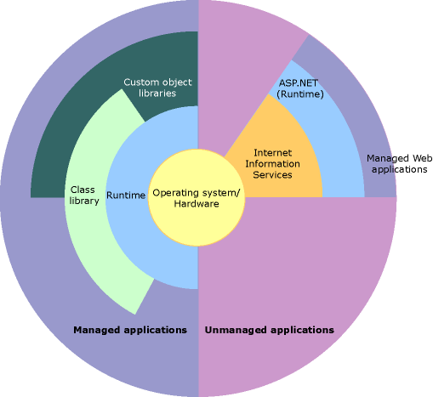
Figure 2.1: .NET Framework in context

Features of the Common Language Runtime
The common language runtime manages memory, thread execution, code execution, code safety verification, compilation, and other system services. These features are intrinsic to the managed code that runs on the common language runtime.
With regards to security, managed components are awarded varying degrees of trust, depending on a number of factors that include their origin (such as the Internet, enterprise network, or local computer). This means that a managed component might or might not be able to perform file-access operations, registry-access operations, or other sensitive functions, even if it is being used in the same active application.
The runtime enforces code access security. For example, users can trust that an executable embedded in a Web page can play an animation on screen or sing a song, but cannot access their personal data, file system, or network. The security features of the runtime thus enable legitimate Internet-deployed software to be exceptionally feature rich.
The runtime also enforces code robustness by implementing a strict type-and-code-verification infrastructure called the common type system (CTS). The CTS ensures that all managed code is self-describing. The various Microsoft and third-party language compilers generate managed code that conforms to the CTS. This means that managed code can consume other managed types and instances, while strictly enforcing type fidelity and type safety.
In addition, the managed environment of the runtime eliminates many common software issues. For example, the runtime automatically handles object layout and manages references to objects, releasing them when they are no longer being used. This automatic memory management resolves the two most common application errors, memory leaks and invalid memory references.
The runtime also accelerates developer productivity. For example, programmers can write applications in their development language of choice, yet take full advantage of the runtime, the class library, and components written in other languages by other developers. Any compiler vendor who chooses to target the runtime can do so. Language compilers that target the .NET Framework make the features of the .NET Framework available to existing code written in that language, greatly easing the migration process for existing applications.
While the runtime is designed for the software of the future, it also supports software of today and yesterday. Interoperability between managed and unmanaged code enables developers to continue to use necessary COM components and DLLs.
The runtime is designed to enhance performance. Although the common language runtime provides many standard runtime services, managed code is never interpreted. A feature called just-in-time (JIT) compiling enables all managed code to run in the native machine language of the system on which it is executing. Meanwhile, the memory manager removes the possibilities of fragmented memory and increases memory locality-of-reference to further increase performance.
Finally, the runtime can be hosted by high-performance, server-side applications, such as Microsoft SQL Server and Internet Information Services (IIS). This infrastructure enables you to use managed code to write your business logic, while still enjoying the superior performance of the industry's best enterprise servers that support runtime hosting.

.NET Framework Class Library
The .NET Framework class library is a collection of reusable types that tightly integrate with the common language runtime. The class library is object oriented, providing types from which your own managed code can derive functionality. This not only makes the .NET Framework types easy to use, but also reduces the time associated with learning new features of the .NET Framework. In addition, third-party components can integrate seamlessly with classes in the .NET Framework.
For example, the .NET Framework collection classes implement a set of interfaces that you can use to develop your own collection classes. Your collection classes will blend seamlessly with the classes in the .NET Framework.
As you would expect from an object-oriented class library, the .NET Framework types enable you to accomplish a range of common programming tasks, including tasks such as string management, data collection, database connectivity, and file access. In addition to these common tasks, the class library includes types that support a variety of specialized development scenarios. For example, you can use the .NET Framework to develop the following types of applications and services:
- Console applications.
- Windows GUI applications (Windows Forms).
- Windows Presentation Foundation (WPF) applications.
- ASP.NET applications.
- Windows services.
- Service-oriented applications using Windows Communication Foundation (WCF).
- Workflow-enabled applications using Windows Workflow Foundation (WF).

2.1.2 Visual C#

C# is an elegant and type-safe object-oriented language that enables developers to build a variety of secure and robust applications that run on the .NET Framework. You can use C# to create Windows client applications, XML Web services, distributed components, client-server applications, database applications, and much, much more. Visual C# provides an advanced code editor, convenient user interface designers, integrated debugger, and many other tools to make it easier to develop applications based on the C# language and the .NET Framework.
C# syntax is highly expressive, yet it is also simple and easy to learn. The curly-brace syntax of C# will be instantly recognizable to anyone familiar with C, C++ or Java. Developers who know any of these languages are typically able to begin to work productively in C# within a very short time. C# syntax simplifies many of the complexities of C++ and provides powerful features such as nullable value types, enumerations, delegates, lambda expressions and direct memory access, which are not found in Java. C# supports generic methods and types, which provide increased type safety and performance, and iterators, which enable implementers of collection classes to define custom iteration behaviors that are simple to use by client code. Language-Integrated Query (LINQ) expressions make the strongly-typed query a first-class language construct.
As an object-oriented language, C# supports the concepts of encapsulation, inheritance, and polymorphism. All variables and methods, including the Main method, the application's entry point, are encapsulated within class definitions. A class may inherit directly from one parent class, but it may implement any number of interfaces. Methods that override virtual methods in a parent class require the override keyword as a way to avoid accidental redefinition. In C#, a struct is like a lightweight class; it is a stack-allocated type that can implement interfaces but does not support inheritance.
In addition to these basic object-oriented principles, C# makes it easy to develop software components through several innovative language constructs, including the following:
- Encapsulated method signatures called delegates, which enable type-safe event notifications.
- Properties, which serve as accessors for private member variables.
- Attributes, which provide declarative metadata about types at run time.
- Inline XML documentation comments.
- Language-Integrated Query (LINQ) which provides built-in query capabilities across a variety of data sources.

If you have to interact with other Windows software such as COM objects or native Win32 DLLs, you can do this in C# through a process called "Interop." Interop enables C# programs to do almost anything that a native C++ application can do. C# even supports pointers and the concept of "unsafe" code for those cases in which direct memory access is absolutely critical.
The C# build process is simple compared to C and C++ and more flexible than in Java. There are no separate header files, and no requirement that methods and types be declared in a particular order. A C# source file may define any number of classes, structs, interfaces, and events.

.NET Framework Platform Architecture for C#
C# programs run on the .NET Framework, an integral component of Windows that includes a virtual execution system called the common language runtime (CLR) and a unified set of class libraries. The CLR is the commercial implementation by Microsoft of the common language infrastructure (CLI), an international standard that is the basis for creating execution and development environments in which languages and libraries work together seamlessly.
Source code written in C# is compiled into an intermediate language (IL) that conforms to the CLI specification. The IL code and resources, such as bitmaps and strings, are stored on disk in an executable file called an assembly, typically with an extension of .exe or .dll.
When the C# program is executed, the assembly is loaded into the CLR, which might take various actions based on the information in the manifest. Then, if the security requirements are met, the CLR performs just in time (JIT) compilation to convert the IL code to native machine instructions. The CLR also provides other services related to automatic garbage collection, exception handling, and resource management. The following diagram illustrates the compile-time and run-time relationships of C# source code files, the .NET Framework class libraries, assemblies, and the CLR.
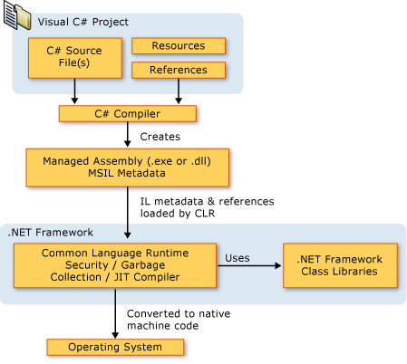
Figure 2.2: Architecture of C# in .Net

2.1.3 ASP.Net

ASP.NET is a unified Web development model that includes the services necessary for you to build enterprise-class Web applications with a minimum of coding. ASP.NET is part of the .NET Framework, and when coding ASP.NET applications you have access to classes in the .NET Framework. You can code your applications in any language compatible with the common language runtime (CLR), including Microsoft Visual Basic and C#. These languages enable you to develop ASP.NET applications that benefit from the common language runtime, type safety, inheritance, and so on.
If you want to try ASP.NET, you can install Visual Web Developer Express using the Microsoft Web Platform Installer, which is a free tool that makes it simple to download, install, and service components of the Microsoft Web Platform. These components include Visual Web Developer Express, Internet Information Services (IIS), SQL Server Express, and the .NET Framework. All of these are tools that you use to create ASP.NET Web applications. You can also use the Microsoft Web Platform Installer to install open-source ASP.NET and PHP Web applications.

The Three Flavors of ASP.NET: Web Forms, MVC, and Web Pages
ASP.NET offers three frameworks for creating web applications: ASP.NET Web Forms, ASP.NET MVC, and ASP.NET Web Pages. All three frameworks are stable and mature, and you can create great web applications with any of them.
Each framework targets a different audience or type of application. Which one you choose depends on a combination of your web development experience, what framework you’re most comfortable with, and which is the best fit for the type of application you’re creating. All three frameworks will be supported, updated, and improved in future releases of ASP.NET.

ASP.NET Web Forms (.aspx pages)
The Web Forms framework targets developers who prefer declarative and control-based programming, such as Microsoft Windows Forms (WinForms) and WPF/XAML/Silverlight. It offers a WYSIWYG designer-driven (drag-and-drop) development model, so it's popular with developers looking for a rapid application development (RAD) environment for web development. If you’re new to web programming and are familiar with the traditional Microsoft RAD client development tools (for example, for Visual Basic and Visual C#), you can quickly build a web application without having expertise in HTML and JavaScript.
Web Forms works well for small teams of Web developers and designers who want to take advantage of the large number of components available for rapid application development. In general, creating a Web Forms application requires less programming effort than creating the same application by using the ASP.NET MVC framework. The components (the Page class, controls, and so on) are tightly integrated and usually require less code than ASP.NET MVC applications. However, Web Forms is not just for rapid application development. There are many complex commercial apps and app frameworks built on top of Web Forms.

ASP.NET MVC
ASP.NET MVC targets developers who are interested in patterns and principles like test-driven development, separation of concerns, inversion of control (IoC), and dependency injection (DI). This framework encourages separating the business logic layer of a web application from its presentation layer.
By dividing the application into the model (M), views (V), and controllers (C), ASP.NET MVC can make it easier to manage complexity in larger applications. With ASP.NET MVC, you can have multiple teams working on a web site because the code for the business logic is separate from the code and markup for the presentation layer — developers can work on the business logic while designers work on the markup and JavaScript that is sent to the browser.
With ASP.NET MVC, you work more directly with HTML and HTTP than in Web Forms. Web Forms tends to hide some of that by mimicking the way you would program a WinForms or WPF application. For example, Web Forms can automatically preserve state between HTTP requests, but you have to code that explicitly in MVC. The MVC model enables you to take complete control over exactly what your application is doing and how it behaves in the web environment.
MVC was designed to be extensible, providing power developers the ability to customize the framework for their application needs. In addition, the ASP.NET MVC source code is available under an OSI license.

ASP.NET Web Pages (.cshtml and .vbhtml files)
ASP.NET Web Pages targets developers who want a simple web development story, along the lines of PHP. In the Web Pages model, you create HTML pages and then add server-based code to the page in order to dynamically control how that markup is rendered. Web Pages is specifically designed to be a lightweight framework, and it's the easiest entry point into ASP.NET for people who know HTML but might not have broad programming experience — for example, students or hobbyists. It's also a good way for web developers who know PHP or similar frameworks to start using ASP.NET.
Like Web Forms, Web Pages is oriented toward rapid development. Web Pages provides components called helpers that you can add to pages and that let you use just a few lines of code to perform tasks that would either be tedious or complex. For example, there are helpers to display database data, add a Twitter feed, log in using Facebook, add maps to a page, and so on.

ASP.NET Compiler
All ASP.NET code is compiled, which enables strong typing, performance optimizations, and early binding, among other benefits. Once the code has been compiled, the common language runtime further compiles ASP.NET code to native code, providing improved performance.
ASP.NET includes a compiler that will compile all your application components including pages and controls into an assembly that the ASP.NET hosting environment can then use to service user requests.

2.1.4 SQL SERVER

SQL Server is a client / server Relational Database Management System (RDBMS) which has been developed by Microsoft and is made up several different client and server programs that make up the entire product.
SQL Server Database Engine (Server)
SQL Server's database engine is the primary server application of the SQL server package. Its main functions are:
- Provide reliable storage
- Rows of data are stored as pages, each 8kb in size.
- Provide a means to rapidly access the data; this is done through utilizing indexes both clustered and non-clustered to search for data, which removes the need for all data to be scanned from the database tables.
- Ensure consistent access to the data; Consistent access basically means only allowing one client to modify/changing the data at any one time
- Implement security; Microsoft SQL Server has multiple security levels Server Level, database level and database object level. Access to the server can be controlled by a Username or password or through Windows security in LAN/Networked environment.
- Enforce data integrity; ensure the data stays consistent.
The ITS Systems Database team offers standards-based, professionally managed SQL Server database systems including hardware, software, and system administration for University of Texas customers. The Microsoft SQL Server database servers may be used for websites, commercial applications, and custom applications designed and built by the customer. The central Microsoft SQL Server database servers are shared to minimize cost and ensure efficient use of the service resources. This service provides three database environments to support the full application development life cycle. The included environments are Development, Quality Assurance (QA), and Production. This service includes database/system administration, database backups and recovery, and monitoring.
Features
- Microsoft SQL Server 2012 environment with Always On Availability Group configuration
- 10 gigabytes of storage space on the central Microsoft SQL Server database servers
- Daily production backups (at minimum) with a four-week retention
- Ability to safely store Confidential Data in databases
- Access to the ITS Systems Microsoft SQL Server team for advice and troubleshooting

In the Fully Managed infrastructure, ITS owns, manages, and supports the SQL Server hardware and host server software resources. The Fully Managed ITS shared SQL Server service is recommended for departments, colleges, or other groups that require SQL Server database service. ITS provides the hardware, software, and staff resources to manage the central SQL Server infrastructure. It is also recommended for those who may be using Confidential Data in their databases.
2.2 EXISTING SYSTEM
There are many village development Systems available in today’s market. The systems will only focus on one village and their problems. There will be no direct interaction between users and donors. There is no system that will display the problems of the village directly into the web. This system cannot provide the information sharing by 24X7. If any information is need to be share between group members it is done either manually or by mailing. The collecting of problems of a village is done by group members only. Maintaining information about every village is a big task. Only face to face communication is possible between the group members and village people. It maintains only problems list about every village and no additional information about villages is unavailable. The existing system is semi automated at which the information is stored in the form of excel sheets in disk drivers. In the existing system it is difficult to know the problem of every village and provide a solution to them. People who want to help the villages must contact the village persons to know problems. It is difficult to club the problems. In the existing system compared to computer work manual work is high. Here there is no way for a village person to submit a problem directly to the village problem list. It takes too much of time to read the problems of every village. In existing system only village problems are available in the record of villages. No additional information is available about villages like primary education, weather conditions, population, tourist places and more. If any information sharing to the group members or voluntaries who works to develop the village is through mailing is more critical in this system.

2.3 PROPOSED SYSTEM WITH FEATURE
The development of this new web-enabled system named as “Mapping Troubles” objective is to provide the solution of the existing system. By using this new system, we can fully automate the entire the process of the current system. The new system is a charity group of professionals those who want to voluntarily contribute in their village/town’s development. Issues like primary education, people’s health, government policies awareness and availability of basic facilities/ infrastructure are on main focus among others. Being a web-enabled system, the process can be accessed across the world over net. This system also providing the features like Chatting , Mailing between the members.
The System “Mapping Troubles” solves all these problems. In the present system we developed an Application that will focus on all villages and their problems. MTS will display the problems faced by the villages. The existing system is semi automated at which the information is stored in the form of excel sheets in disk drivers. In the existing system

CHAPTER 3
SOFTWARE REQUIREMENTS SPECIFICATION
A Software requirements specification (SRS), a requirements specification for a software system, is a complete description of the behavior of a system to be developed and may include a set of use cases that describe interactions the users will have with the software. In addition it also contains non-functional requirements. Non-functional requirements impose constraints on the design or implementation (such as performance engineering requirements, quality standards, or design constraints).
The software requirements specification document enlists all necessary requirements that are required for the project development.^{[1]} To derive the requirements we need to have clear and thorough understanding of the products to be developed. This is prepared after detailed communications with the project team and customer.
The SRS may be one of a contract deliverable Data Item Descriptions [or have other forms of organizationally-mandated content. An example organization of an SRS is as follows:
Specific requirements:
- External interface requirements
- Functional requirements
- Performance requirements
- Design constraints
  - Standards Compliance
- Logical database requirement
- Software System attributes
  - Reliability
  - Availability
  - Security
  - Maintainability

3. SPECIFICATIONS REQUIREMENTS

Hardwar Requirements:
Language Specification C# with Asp.Net
Databases SQLSERVER 2008
Framework .Net 4.0
IDE: Visual Studio 2010
Operating Systems Windows 2000, Windows NT 4.0, Windows& Above

Software Requirements:
Processor Pentium IV & LATERs
RAM 512MB RAM & above
Hard Disk 80GB & above

3.3 Functional Requirements:
” In software engineering, a functional requirement defines a function of a software system or its component. A function is described as a set of inputs, the behavior, and outputs (see also software).
Functional requirements may be calculations, technical details, data manipulation and processing and other specific functionality that define what a system is supposed to accomplish. Behavioral requirements describing all the cases where the system uses the functional requirements are captured in use cases. Functional requirements are supported by non-functional requirements (also known as quality requirements), which impose constraints on the design or implementation (such as performance requirements, security, or reliability). How a system implements functional requirements is detailed in the system design.
As defined in requirements engineering, functional requirements specify particular results of a system. This should be contrasted with non-functional requirements which specify overall characteristics such as cost and reliability. Functional requirements drive the application architecture of a system, while non-functional requirements drive the technical architecture of a system.
The Functional Requirements of our site “XXXXXXXXXXare
- xxxxxxxxxxxxxxxxxxxxxxxxxxxxxxxxxxxxxxxxxxxxxxxxxxx
- xxxxxxxxxxxxxxxxxxxxxxxxxxxxxxxxxxxxxxxxxxxxxxxxxxxxxxxxx
- xxxxxxxxxxxxxxxxxxxxxxxxxxxxxxxxxxxxxxxxxxxxxxxxxxxxxxxxx
Non-Functional Requirements:
In systems engineering and requirements engineering, a non-functional requirement is a requirement that specifies criteria that can be used to judge the operation of a system, rather than specific behaviors. This should be contrasted with functional requirements that define specific behavior or functions.
In general, functional requirements define what a system is supposed to do whereas non-functional requirements define how a system is supposed to be. Non-functional requirements are often called qualities of a system. Other terms for non-functional requirements are "constraints", "quality attributes", "quality goals" and "quality of service requirements". Qualities, that is, non-functional requirements, can be divided into two main categories:
- Execution qualities, such as security and usability, which are observable at run time.
- Evolution qualities, such as testability, maintainability, extensibility and scalability, which are embodied in the static structure of the software system.
Software specifications:

Software specifications of the system that is used in the project is

- Operating system: WINDOWS 7

- Front end: MICROSOFT VISUAL STUDIO 2012: Microsoft Visual Studio is an Integrated Development Environment from Microsoft .It can be used to develop console and graphical user interface applications along with windows forms applications , websites, web applications and web services in both native code together with managed code for all platforms supported by Microsoft Windows,.NET framework,.NET compact Framework and Microsoft Silver light .It also supports the c# that we use to create web site.

- Back end: SQL SERVER 2008 R2: In this SQL Server Management Studio is a software application first launched with the Microsoft SQL Server 2005 that is used for configuring, managing, and administering all components with in Microsoft SQL Server.

- Microsoft Office Word 2007: We use Microsoft Office Word 2007 to do our documentation of this project. This is very important for us to do this project. We have use the feature of text box to draw the hierarchical chart to describe the various of subsystem, modules and sub-modules in the system. It also uses to check our spelling and grammar and justify all the words to make our document look nicer.

4. DESIGN
DATA FLOW DIAGRAMS
Data flow diagrams:
Data flow diagrams (“bubble charts”) are directed graphs in which the nodes specify processing activities and the arcs specify data items transmitted between processing nodes. A data flow diagram might represent data flow between individual statements or blocks of statements in a routine, data flow between sequential routines, data flow between concurrent process, or data flow in a distributed computing system, where each node represents a geographically remote processing unit.
Unlike flow charts, data flow diagrams do not indicate decision logic or condition under which various nodes in the diagram might be activated. Data flow diagrams can be expressed using special symbols. These symbols can be used to denote processing nodes, data nodes, data sources and data stores.
A Data Flow Diagram (DFD) is a graphical technique that depicts information flow and transforms that are applied as data move to represent a system or software at any level of abstraction. Data Flow Diagram may be partitioned into levels that represent increasing information flow and functional detail. The notation used to create a DFD is illustrated in the given as:
- Process: A Process transforms incoming data flow(s) into outgoing data flow(s).
- External Entity: An External Entity is a system element (hardware a person) that produces information for transformation by the software or received information produced by the software.
- Data Store: A repository of data for the use of one or more process.
- Arrow ( → ):A data item or collection of data items, the arrowhead indicates the direction of data flow.

DFD SYMBOLS
In the DFD, there are four symbols
A square defines a source (originator) or destination of system data
An arrow identifies data flow. It is the pipeline through which the information flows
A circle or a bubble represents a process that transforms incoming data flow into outgoing data flows.
An open rectangle is a data store, data at rest or a temporary repository of data

Data Flow

Processing Node

Source or Destination

Data Store

SAILENT FEATURES OF DFD’S

- The DFD shows flow of data, not of control loops and decision are controlled considerations do not appear on a DFD.
- The DFD does not indicate the time factor involved in any process whether the dataflow take place daily, weekly, monthly or yearly.
- The sequence of events is not brought out on the DFD.

- TYPES OF DATA FLOW DIAGRAMS
- Current Physical
- Current Logical
- New Logical
- New Physical

CURRENT PHYSICAL
In Current Physical DFD process label include the name of people or their positions or the names of computer systems that might provide some of the overall system-processing label includes an identification of the technology used to process the data. Similarly data flows and data stores are often labels with the names of the actual physical media on which data are stored such as file folders, computer files, business forms or computer tapes.
CURRENT LOGICAL
The physical aspects at the system are removed as much as possible so that the current system is reduced to its essence to the data and the processors that transforms them regardless of actual physical form.

NEW LOGICAL
This is exactly like a current logical model if the user were completely happy with the user were completely happy with the functionality of the current system but had problems with how it was implemented typically through the new logical model will differ from current logical model while having additional functions, absolute function removal and inefficient flows recognized.
NEW PHYSICAL
The new physical represents only the physical implementation of the new system

Different Types of Blocks used in DFD’s:

Top-down approach:
- The system designer makes a context level DFD or Level 0, which shows the "interaction" (data flows) between "the system" (represented by one process) and "the system environment" (represented by terminators).
- The system is "decomposed in lower-level DFD (Level 1)" into a set of "processes, data stores, and the data flows between these processes and data stores".
- Each process is then decomposed into an "even-lower-level diagram containing its sub processes".
- This approach "then continues on the subsequent sub processes", until a necessary and sufficient level of detail is reached which is called the primitive process (aka chewable in one bite).
DFD is also a virtually designable diagram that technically or diagrammatically describes the inflow and outflow of data or information that is provided by the external entity.

Context Level DFD:

A context level Data flow diagram created using select SSADM. This level shows the overall context of the system and its operating environment and shows the whole system as just one process. It does not usually show data stores, unless they are "owned" by external systems, e.g. are accessed by but not maintained by this system, however, these are often shown as external entities.

Detailed Level DFD:
A detailed level Data flow diagram shows the overall context of the system and its operating environment and shows the whole system in detailed form, i.e. by seeing the DFD we can say that what happens after each and every step. The purpose of this level is to show the major and high-level processes of the system and their interrelation. A process model will have one, and only one, level-1 diagram. A level-1 diagram must be balanced with its parent context level diagram, i.e. there must be the same external entities and the same data flows, these can be broken down to more detail in the level 1, example the "inquiry" data flow could be split into "inquiry request" and "inquiry results" and still be valid.

Data Flow Diagrams:
Context Level DFD/LEVEL 0:

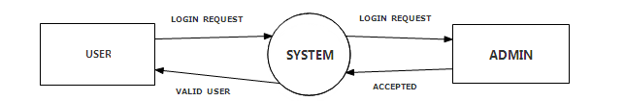

UML Diagrams:

UML DATA

The UML’s four structural diagram exists to visualize, specify, construct and document the static aspects of system. Just as the static aspects of a house encompass the existence and placement of such things as walls, doors, windows, pipes, wires and vents. So to do the static aspects of a software system encompass the existence and placement of such things classes, interfaces, collaborations, components and nodes.
The UML’s structural diagrams are roughly organized around the major groups of things you will find when modeling a system.

- CLASS DIAGRAM:
- COMPONENT DIAGRAM:
- DEPLOYMENT DIAGRAM:
- Sequence Diagram
- Collaboration Diagram
- State chart Diagram
- Activity Diagram
- Deployment Diagram

CLASS DIAGRAM:
A class diagram shows a set of classes, interfaces, collaborations and their relationships. Class diagrams are the most common diagrams found in modeling object – oriented system. Class diagram that includes active classes are used to address the static process view of a system.
COMPONENT DIAGRAM:
A component diagram shows a set of components and their relationships. Component diagrams are related to class diagrams in that component typically maps to one or more classes, interfaces or collaborations. It is used to illustrate the static implementation view of a system.
DEPLOYMENT DIAGRAM:
A deployment diagrams shows a set of nodes and their relationships deployment diagrams are related to component diagrams in that node typically encloses one or more components.

USECASE DIAGRAMS:
A use case diagram shows as set of use cases and actors and their relationships. Use case diagrams are especially important in organizing and modeling behavior of a system.

SEQUENCE DIAGRAM:
A sequence diagram is an interaction diagram that emphasizes the time ordering of messages. A sequence diagram shows a set of objects and messages sent and receive by those objects. The objects are typically named or anonymous instances of other things, such as collaborations, components and nodes. We can use sequence diagrams to illustrate the dynamic view of a system.
COLLABORATION DIAGRAM:
A collaboration diagram is an inter action diagram that emphasizes the structural organization of the objects that send and receive messages. It shows a set of objects, links among those objects and messages sent and receive by the objects. The objects are typically named or anonymous instances of classes but may also represent instance of other things such as collaborations, components and nodes.

RELATIONSHIPS
1. Dependency:
Dependency is a semantic relationship between two things in which change to one thing may affect the semantics of other things.
Graphically a dependency rendered as a dashed-line, possibly directed occasionally including a label.

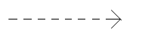
Fig: Dependency

2. Association:
Association is a structural relationship that describes set of links.
a link being a connection among objects. Aggregation is a special kind of association a structural relationship between a whole and its parts.
It is graphically rendered as a solid-line. Such as multiplicity and role names.

_________________
Employer employee

Fig: Association

Generalization:

Generalization is a specialization/generalization relationship in which objects of specialized element (child) are substitutable for object of the generalized element (parent).in this way the child shares the structure and behavior of the parent.
Graphically rendered as a solid-line with a hollow over-head pointing to the parent.
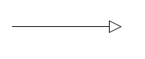 Fig: Generalization
4. Realization:
A realization is a semantic relationship between classifiers. Where in one classifier specifies a contract that another classifier guarantees to carry-out you will encounter relationships in two places between interfaces and classes or components between use case collaborations.
Graphically rendered as cross between generalization and dependency relationships.

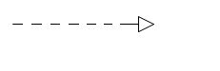 Fig: Realization

5. Class:
A class is a description of set of objects and the same attributes, operations relationships and semantics. A class implements one or more interfaces.
Graphically rendered as a rectangle, usually including a name, attributes and operations.
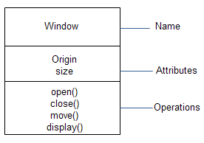
Fig: Classes

6. Use case:
Use case is a description of set of sequence of actions that a system performs that yields an observable result of value to a particular actor.
Graphically rendered as an ellipse with solid-lines, usually including only its names. 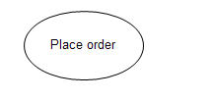
Fig: Use case

- Collaborations:

Collaboration defines an interaction is a society of roles and other elements that work together to provide some co-operative behavior that’s bigger than the some of elements. Therefore collaborations have structural as well as behavioral dimensions.
Graphically rendered as an ellipse with dashed-lines usually including only its names.

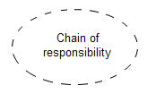
Fig: collaboration

- Component:

A component is a physical and replicable part of a system that confirms to provide the relation of set of interfaces. In a system we can find and encounter different kinds of deployment components such as com+ components and java-beans.
A component typically represents the physical package logical elements such as classes, interfaces and collaborations.
It is graphically rendered as rectangle with tabs usually including only it’s names.
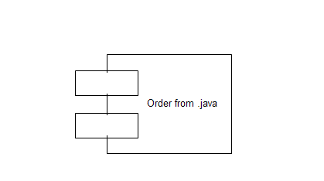
Fig: Component

- Node:

A node is a physical element that exists at run-time and represents a computational resources generally having at least some memory and often processing capability.
Graphically rendered as a cube, usually including only its names.

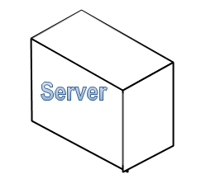 Fig: Node

Use case Diagram

The use case diagram is used to identify the primary element and processes. That form the system the primary element are termed as “actors” and the processes are called “use cases”.
The use case diagram show which actors interacts with each use case.
Use case diagram of UML are used to view system from this perspective as a set of discrete Activities or transactions.
A ellipse represents a use case and a
“Stick figure” represents an actor operating with in the use case.
- An actor can be user, system or other entity.
- The initiating actor appears on the left of the use case and the receiving actor appears on the right.
- The actor is identified by a name below the “stick figure”
- The name of the use case appears either in the side or below the ellipse.
- An association line is a that connects an actor and to the use case and represents communication between the actor and use cases
- The association line is solid similar to the line that connect associated classes.
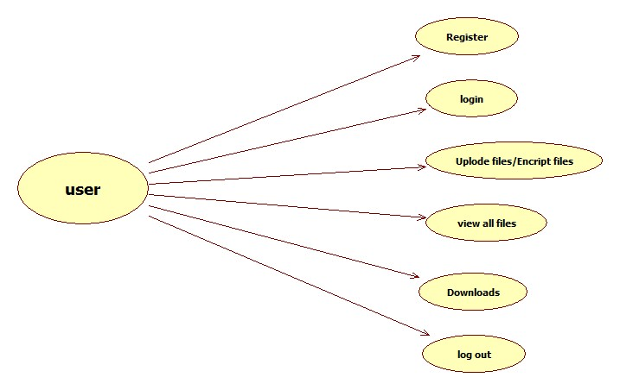

Fig: Usecase for User
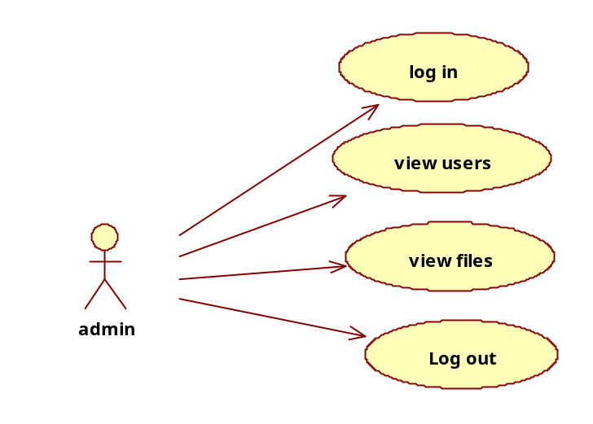
Fig: Usecase for Admin

Class diagram:

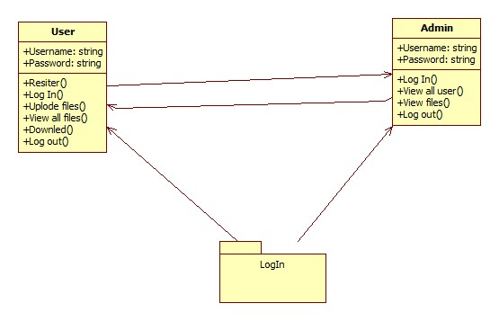

Activity diagram:
The process flows in the system are captured in the activity diagram similar to a state diagram an activity diagram also consists of activities, action, transitions
- Initial and final states and guard conditions
- Processes involving different use case are show in work flows.

Example: from ordering to delivery and payment activity diagram describe the work slow behavior of a system.

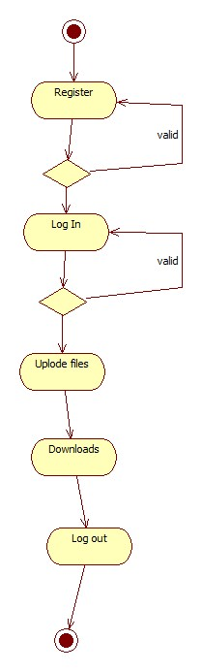
Fig: Activity Diagram For user
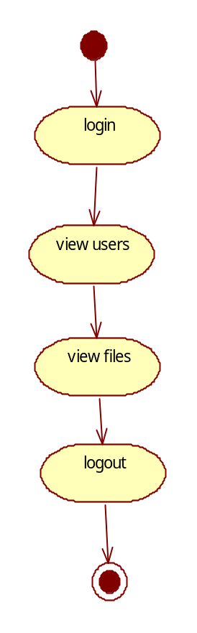
Fig: Activity diagram for Admin

Sequence diagram:

A sequence diagram is an interaction diagram that details how operations are carried out. What message are sent and when sequence diagram are organized according to time it represents the interaction between different objects in the system.

The important aspects of a sequence diagram are that it is time ordered.

This means that the exact sequence of the interaction between the object is represented step by step different objects in the sequence diagram interact with each other by passing message.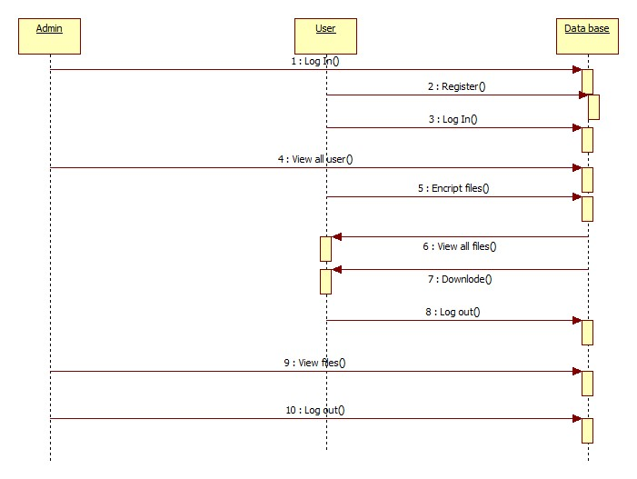

COLLABORATION DIAGRAM:

A collaboration diagram is an inter action diagram that emphasizes the structural organization of the objects that send and receive messages. It shows a set of objects, links among those objects and messages sent and receive by the objects. The objects are typically named or anonymous instances of classes but may also represent instance of other things such as collaborations, components and nodes.

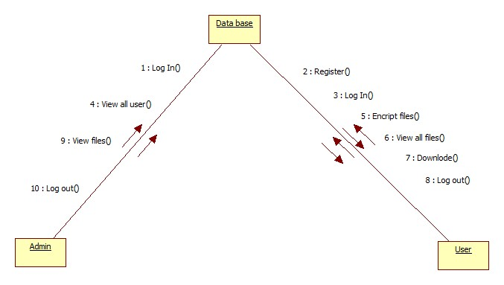
Fig: Collaboration Diagram

CHAPTER-5

IMPLEMENTATION

It is the process of bringing developed system of revised system into operational use.Ifthe implementation phase is not carefully planned and controlled, it can lead to many problems. Thus proper implementation is essential to provide a reliable system to meet managerial requirements.
The application is completely written .net .This enables the debit card issues to use this application across a variety of devices independent of the vendor of the devices. We use sql as a back end for storing database.
5.1: TECHNOLOGY USED:
5.1.1: Dot Net:
The .NET Framework (pronounced dot net) is a proprietary, partially open source freeware software framework developed by Microsoft that runs primarily on Microsoft Windows.
5.1.2: What is Dot Net?
The .NET is the technology from Microsoft, on which all other Microsoft technologies will be depending on in future. It is a major technology change, introduced by Microsoft, to catch the market from the SUN's Java. Few years back, Microsoft had only VC++ and VB to compete with Java, but Java was catching the market very fast. With the world depending more and more on the Internet/ Web and java related tools becoming the best choice for the web applications, Microsoft seemed to be losing the battle. Thousands of programmers moved to java from VC++ and VB. To recover the .market, .Microsoft announced .NET.
But Microsoft has a wonderful history of starting late but catching up quickly. This is true in case of .NET too. Microsoft put their best men at work for a secret project called Next Generation Windows Services (NGWS)., under the direct supervision of Mr. Bill Gates.
The outcome of the project is what we now know as .NET. Even though .NET has borrowed most of its ideas from Sun's J2EE, it has really outperformed their competitors.
Microsoft's VC++ was a powerful tool. But it was too complex. It has too many data types, and developers had to learn many libraries including Windows SDK, MFC, ATL, COM etc. There were many data type compatibility issues while exchanging data between different layers. Visual Basic was too easy, and many serious programmers hated it just for that reason. Even though Visual basic was very easy to use, it was not very flexible to develop serious applications. SUN's Java became a very good choice for these reasons. It had the flexibility and power of C++ and at the same time easy enough to catch the attention of VB programmers.

4.1.4: The structure of Dot Net:
It is a platform for application developers.
It is a Framework that supports Multiple Language and Cross language integration.
IT has IDE (Integrated Development Environment).
Framework is a set of utilities or can say building blocks of your application system.
.NET Framework provides GUI in a GUI manner.
.NET is a platform independent but with help of Mono Compilation System (MCS). MCS is a middle level interface.
.NET Framework provides interoperability between languages i.e. Common Type System (CTS).
.NET Framework also includes the .NET Common Language Runtime (CLR), which is responsible for maintaining the execution of all applications developed using the .NET library.
The .NET Framework consists primarily of a gigantic library of code.

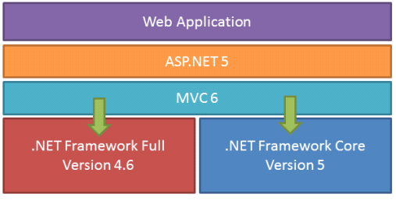

Class Library:
.NET Framework includes a set of standard class libraries. The class library is organized in a hierarchy of namespaces. Most of the built-in APIs are part of either system or Microsoft namespaces. These class libraries implement a large number of common functions, such as file reading and writing, graphic rendering, database interaction, and XML document manipulation, among others. .NET class libraries are available to all CLI compliant languages. .NET Framework class library is divided into two parts: Framework Class Library (FCL) and Base Class Library (BCL).
FCL includes a small subset of the entire class library and is the core set of classes that serve as the basic API of CLR. Classes in and some classes.inSystem.dll and System.core.dll are part of FCL. FCL classes are available in .NET Framework as well as its alternative implementations including .NET Compact Framework, Microsoft Silverlight and Mono.
BCL is a superset of FCL and refers to the entire class library that ships with .NET Framework. It includes an expanded set of libraries, including Windows Forms, ADO.NET, ASP.NET, Language Integrated Query (LINQ), Windows Presentation Foundation (WPF), Windows Communication Foundation (WCF) and Workflow Foundation (WF). BCL is much larger in scope than standard libraries for languages like C++, and comparable in scope to standard libraries of Java.
.NET Core:
.NET Core is a free and open-source partial implementation of the .NET Framework. It consists of CoreCLR and CoreFX, which are partial forks of CLR and BCL respectively.NET Core comes with an improved JIT compiler, called RyuJIT.
SOURCE CODE:
HOME
<%@ Page Title="" Language="C#" MasterPageFile="~/MasterPage2.master" AutoEventWireup="true" CodeFile="Home.aspx.cs" Inherits="Home" %>

<asp:Content ID="Content1" ContentPlaceHolderID="ContentPlaceHolder1" Runat="Server">
<p>
&nbsp;</p>
<p>
&nbsp;&nbsp;&nbsp;&nbsp;&nbsp;&nbsp;&nbsp;&nbsp;&nbsp;&nbsp;&nbsp;&nbsp;&nbsp;&nbsp;&nbsp;&nbsp;&nbsp;&nbsp;&nbsp;&nbsp;&nbsp;&nbsp;&nbsp;&nbsp;&nbsp;&nbsp;&nbsp;&nbsp;&nbsp;</p>

<p>&nbsp;</p>

<p>
&nbsp;</p>

<p>
</p>
</asp:Content>

LOGIN

<%@ Page Title="" Language="C#" MasterPageFile="~/MasterPage2.master" AutoEventWireup="true" CodeFile="Login.aspx.cs" Inherits="Login" %>

<asp:Content ID="Content1" ContentPlaceHolderID="ContentPlaceHolder1" Runat="Server">
<table align="center">
<tr>
<td>
Login ID:</td>
<td>
<asp:TextBox ID="TextBox1" runat="server"></asp:TextBox>
</td>
</tr>
<tr>
<td >
Password :</td>
<td >
<asp:TextBox ID="TextBox2" runat="server" ontextchanged="TextBox2_TextChanged"
TextMode="Password"></asp:TextBox>
</td>
</tr>
<tr>
<td align="center" colspan="2">
<asp:Button ID="Button1" runat="server" onclick="Button1_Click" Text="Login"
Width="80px" />

<asp:Button ID="Button2" runat="server" Text="Clear" onclick="Button2_Click1"
/>
</td>
</tr>
<tr>
<td colspan="2" align="center">If New User?<asp:LinkButton ID="lnkSignup" runat="server" Text="Sign Up" PostBackUrl="~/register2.aspx"></asp:LinkButton></td>
</tr>
</table>
</asp:Content>

REGISTER
<%@ Page Title="" Language="C#" MasterPageFile="~/MasterPage2.master" AutoEventWireup="true" CodeFile="register2.aspx.cs" Inherits="register2" %>

<asp:Content ID="Content1" ContentPlaceHolderID="ContentPlaceHolder1" Runat="Server">
<table style="width: 121%; height: 476px">
<tr>
<td align="left" colspan="2"

style="font-family: 'Segoe Script'; font-size: xx-large; color: #FFFF00; text-decoration: underline">
Registeration form</td>
</tr>
<tr>
<td style="width: 108px">
User name:</td>
<td>
<asp:TextBox ID="txtUName" runat="server" required="required" title="Please Enter User Name"></asp:TextBox>
&nbsp;</td>
</tr>
<tr>
<td style="width: 108px">
Password:</td>
<td>
<asp:TextBox ID="txtPwd" runat="server" TextMode="Password" required="required" title="Please Enter Password"></asp:TextBox>
&nbsp;</td>
</tr>
<tr>
<td style="width: 108px">
Email id:</td>
<td>
<asp:TextBox ID="txtEmail" runat="server" required="required" type="email"></asp:TextBox>
</td>
</tr>
<tr>
<td style="width: 108px">
D.O.B</td>
<td>
<asp:TextBox ID="txtDOB" runat="server" required="required" type="date"></asp:TextBox>
&nbsp;</td>
</tr>
<tr>
<td style="width: 108px">
State:</td>
<td>
<asp:TextBox ID="txtState" runat="server"></asp:TextBox>
&nbsp;</td>
</tr>
<tr>
<td style="width: 108px">
Country:</td>
<td>
<asp:TextBox ID="txtCountry" runat="server"></asp:TextBox>
&nbsp;</td>
</tr>
<tr>
<td style="width: 108px">
Mobile number:</td>
<td>
<asp:TextBox ID="txtMobile" runat="server" MaxLength="10"
pattern="^\d\d\d\d\d\d\d\d\d\d" title="Please Enter Mobile Number"
required="required"></asp:TextBox>
&nbsp;</td>
</tr>
<tr>
<td align="center" style="width: 108px">
<asp:Button ID="btnSubmit" runat="server" Text="Submit"
onclick="btnSubmit_Click" />&nbsp;
</td>
<td align="left">
<asp:Button ID="btnClear" runat="server" Text="Clear"/>
</td>
</tr>
</table>
</asp:Content>
Contact us:
<%@ Page Title="" Language="C#" MasterPageFile="~/MasterPage2.master" AutoEventWireup="true" CodeFile="Contactus.aspx.cs" Inherits="Contactus" %>

<%@ Register assembly="AjaxControlToolkit" namespace="AjaxControlToolkit" tagprefix="asp" %>

<asp:Content ID="Content1" ContentPlaceHolderID="ContentPlaceHolder1" Runat="Server">
<table style="width: 100%">
<tr>
<td align="center">
<h1>
Contact us:</h1>
</td>
</tr>
<tr>
<td>
Name (Requried):</td>
</tr>
<tr>
<td>
<br />
<asp:TextBox ID="TextBox1" runat="server" Width="196px" required="required" title="Please enter your Name" ></asp:TextBox>
</td>
</tr>
<tr>
<td>
Email-Id (requried):<br />
<br />
</td>
</tr>
<tr>
<td>
<asp:TextBox ID="TextBox2" runat="server" required="required" title="Please Email id"></asp:TextBox>
</td>
</tr>
<tr>
<td>
Phone number:<br />
</td>
</tr>
<tr>
<td>
<asp:TextBox ID="TextBox3" runat="server" MaxLength="10" required="required" title="Please Enter your Mobile Number"></asp:TextBox>
</td>
</tr>
<tr>
<td>
Your message :<br />
<asp:TextBox ID="TextBox4" runat="server" Columns="20" Height="141px"
Rows="200" Width="486px"></asp:TextBox>
<br />
<br />
</td>
</tr>
<tr>
<td>
<%--Rate us--%> <%--<asp:Rating ID="Rating1" runat="server" RatingAlign="Horizontal"
MaxRating="5" RatingDirection="LeftToRightTopToBottom"
BehaviorID="Rating1_RatingExtender=&quot;5&quot;" >
</asp:Rating>--%>
</td>
</tr>
<tr>
<td align="left">
<asp:ImageButton ID="ImageButton1" runat="server" Height="34px"
ImageUrl="~/temp/submit.gif" Width="96px" onclick="ImageButton1_Click" />
</td>
</tr>
</table>
</asp:Content>

SCREEN SHOTS

5.2.1 Home Page
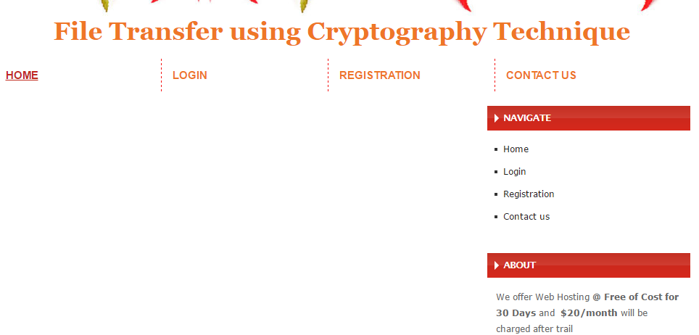
Fig 4.2.1 home Page
4.2.2 login page
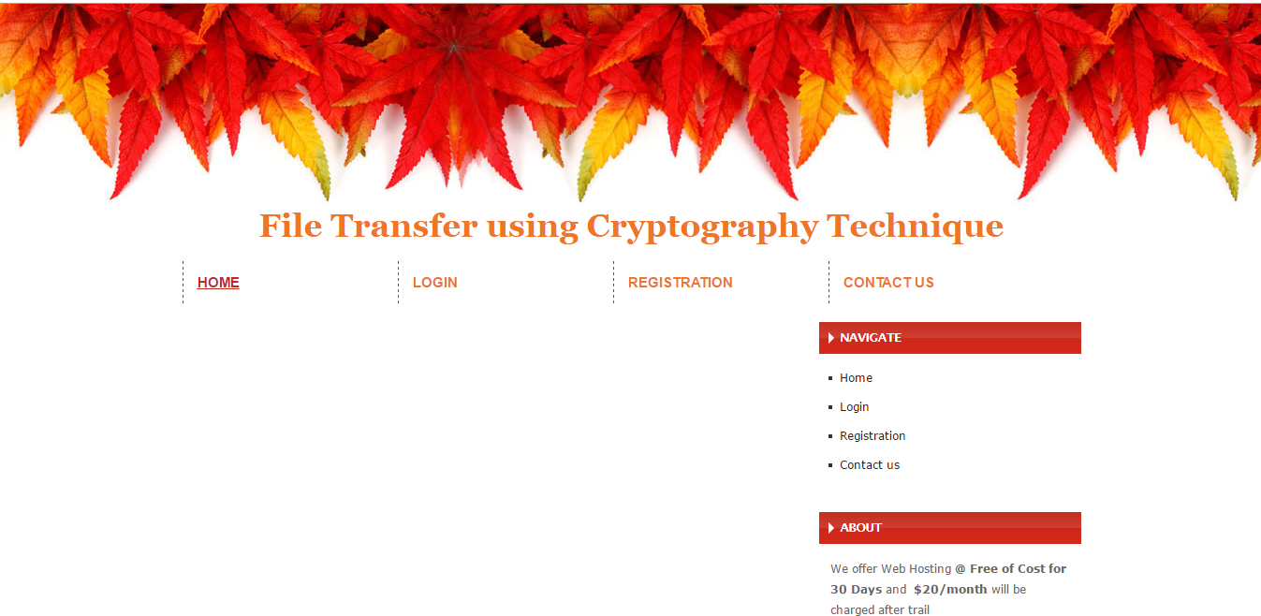
Fig: 4.2.2 login Page

4.2.3 Registration page

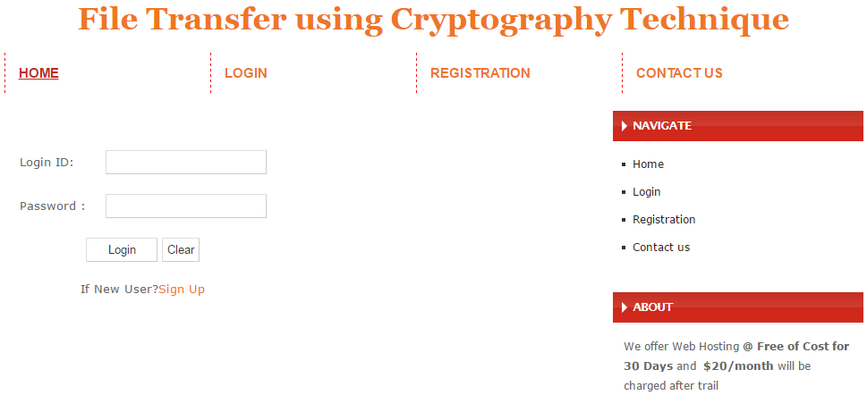

Fig: 4.2.3 Registration pag
4.2.4 Contact us:
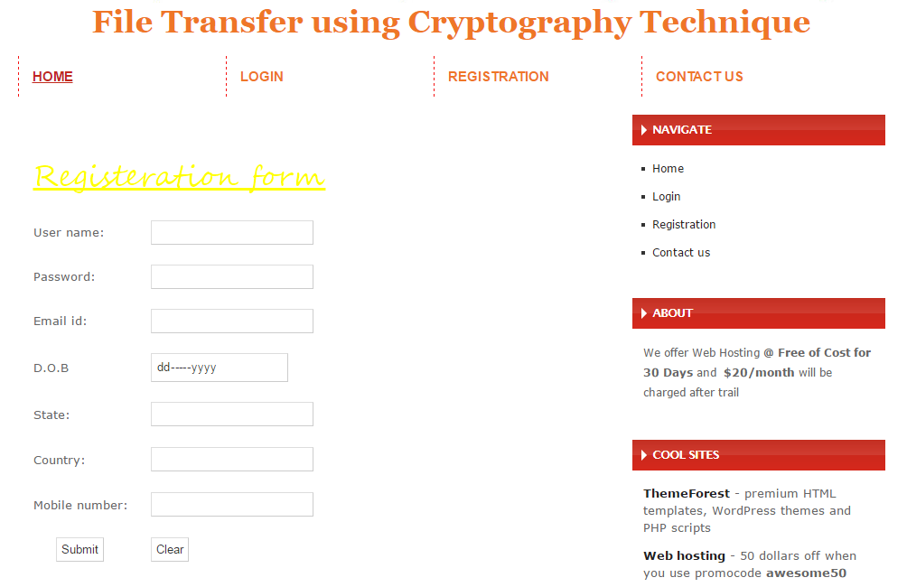 Fig: 4.2.4 Contact us:
6. Testing Concepts

Testing

- Testing Methodologies
          - Black box Testing:
- White box Testing.
- Gray Box Testing.

- Levels of Testing
  - Unit Testing.
  - Module Testing.
  - Integration Testing.
  - System Testing.
  - User Acceptance Testing.

- Types Of Testing
  - Smoke Testing.
  - Sanitary Testing.
  - Regression Testing.
  - Re-Testing.
  - Static Testing.
  - Dynamic Testing.
  - Alpha-Testing.
  - Beta-Testing.
  - Monkey Testing.
  - Compatibility Testing.
  - Installation Testing.
  - Adhoc Testing.
  - Ext….

TCD (Test Case Documentation)
- STLC
  - Test Planning.
  - Test Development.
  - Test Execution.
  - Result Analysis.
  - Bug-Tracing.
  - Reporting.
- Microsoft Windows – Standards
- Manual Testing
- Automation Testing (Tools)
  - Win Runner.
  - Test Director.

Testing:

- The process of executing a system with the intent of finding an error.
- Testing is defined as the process in which defects are identified, isolated, subjected for rectification and ensured that product is defect free in order to produce the quality product and hence customer satisfaction.
- Quality is defined as justification of the requirements
- Defect is nothing but deviation from the requirements
- Defect is nothing but bug.
- Testing --- The presence of bugs
- Testing can demonstrate the presence of bugs, but not their absence
- Debugging and Testing are not the same thing!
- Testing is a systematic attempt to break a program or the AUT
- Debugging is the art or method of uncovering why the script /program did not execute properly.
Testing Methodologies:

- Black box Testing: is the testing process in which tester can perform testing on an application without having any internal structural knowledge of application.
Usually Test Engineers are involved in the black box testing.
- White box Testing: is the testing process in which tester can perform testing on an application with having internal structural knowledge.
Usually the Developers are involved in white box testing.
- Gray Box Testing: is the process in which the combination of black box and white box techniques are used.

Levels of Testing:

Module1Module2Module3
Units |  | Units |  | Units
I/p Integration o/p I/p Integration o/p

System Testing: Presentation + business +Databases
⓪UAT: user acceptance testing

(SOFTWARE TESTING LIFE CYCLE):
Test Planning:
1.how to perform various testing on the total application in the most efficient Test Plan is defined as a strategic document which describes the procedure way.
2. This document involves the scope of testing,
3. Objective of testing,
4. Areas that need to be tested,
5. Areas that should not be tested,
6. Scheduling Resource Planning,
7. Areas to be automated, various testing tools Used….

Test Development:
1. Test case Development (check list)
2. Test Procedure preparation. (Description of the test cases)
Test Execution:
1. Implementation of test cases, observing the result.
Result Analysis:
1. Expected value: is nothing but expected behavior
Of application:
1. Actual value: is nothing but actual behavior of the Application
Bug Tracing:
1. Collect all the failed cases, prepare documents

Reporting:
Prepare document (status of the application) SAS
Types of Testing:
①>Smoke Testing: is the process of initial testing in which tester looks for the availability of all the functionality of the application in order to perform detailed testing on them. (Main check is for available forms)
①>Sanity Testing: is a type of testing that is conducted on an application initially to check for the proper behavior of an application that is to check all the functionality are available before the detailed testing is conducted by on them.
①>Regression Testing: is one of the best and important testing. Regression testing is the process in which the functionality, which is already tested before, is once again tested whenever some new change is added in order to check whether the existing functionality remains same.
①>Re-Testing: is the process in which testing is performed on some functionality which is already tested before to make sure that the defects are reproducible and to rule out the environments issues if at all any defects are there.
①Static Testing: is the testing, which is performed on an application when it is not been executed.
Ex: GUI, Document Testing
①Dynamic Testing: is the testing which is performed on an application when it is being executed. ex: Functional testing.
①Alpha Testing: it is a type of user acceptance testing, which is conducted on an application when it is just before released to the customer.
①Beta-Testing: it is a type of UAT that is conducted on an application when it is released to the customer, when deployed in to the real time environment and being accessed by the real time users.
①Monkey Testing: is the process in which abnormal operations, beyond capacity operations are done on the application to check the stability of it in spite of the user’s abnormal behavior.
①Compatibility testing: it is the testing process in which usually the products are tested on the environments with different combinations of databases (application servers, browsers…etc) In order to check how far the product is compatible with all these environments platform combination.
Installation Testing: it is the process of testing in which the tester try to install or try to deploy the module into the corresponding environment by following the guidelines produced in the deployment document and check whether the installation is successful or not.
Adhoc Testing: Adhoc Testing is the process of testing in which unlike the formal testing where in test case document is used, with out that test case document testing can be done of an application, to cover that testing of the future which are not covered in that test case document. Also it is intended to perform GUI testing which may involve the cosmetic issues.
TCD (Test Case Document):

Test Case Document Contains
- Test Scope (or) Test objective
- Test Scenario
- Test Procedure
- Test case
This is the sample test case document for the Academic details of student project:
Test scope:

- Test coverage is provided for the screen “Academic status entry” form of a student module of university management system application.
- Areas of the application to be tested.
Test Scenario:
- When the office personals use this screen for the marks entry, calculate the status details, saving the information on student’s basis and quit the form.
Test Procedure:
- The procedure for testing this screen is planned in such a way that the data entry, status calculation functionality, saving and quitting operations are tested in terms of GUI testing, Positive testing, Negative testing using the corresponding GUI test cases, Positive test cases, Negative test cases respectively.
Guidelines for Test Cases:

- GUI Test Cases:
- Total no of features that need to be check
- Look & Feel
- Look for Default values if at all any (date & Time, if at all any require)
- Look for spell check

Example for GUI Test cases:

T.no | Description | Expected value | Actual value | Result
1 | Check for all the features in the screen | The screen must contain all the features
2 | Check for the alignment of the objects as per the validations | The alignment should be in proper way
3.Positive Test Cases:

- The positive flow of the functionality must be considered
- Valid inputs must be used for testing
- Must have the positive perception to verify whether the requirements are justified.
Example for Positive Test cases:

T.C.No | Description | Expected value | Actual value | Result
1 | Valid Login | It should accept | It should accept | It should accept
2 | If User want to the File then the key is sent to the email.If the key matches then the File can be downloaded. | It should accept | It should accept | It should accept

3.Negative Test Cases:

- Must have negative perception.
- Invalid inputs must be used for test

Example for Negative Test cases:

T.C.No | Description | Expected value | Actual value | Result
1 | Invalid Username or Password | Modification should not be allow | Modification should not be allow | It should show invalid crediationals
2 | If User want to the File then the key is sent to the email.If the key matches then the File can be downloaded. | It should not accept . | It should not accept . | Show invalid key.

8. CONCLUSION

AES algorithm is used to encrypt files and transmit encrypted files to other end where it is decrypted. The project works efficiently for small size while it consumes time for large size of files. At a instant only one file can be encrypted and Key is send to the Particular login User Email. As a future work multiple file encryption and decryption can be possible. It has broad development prospects. The project application was designed to take the efficiency and reusability into account. Great level of security is achieved using this algorithm. Modified AES algorithm for file transmission algorithm can be used where high security file transmission required in public forums.

CHAPTER-9
FUTURE SCOPE AND ENHANCEMENTS
- We can enhance this desktop application to web application also.
- Give new User registration authentic by administrator.
- Each Admin Login.
- Each User reseter.
- Each User Login.
.

10. BIBILIOGRAPHY

For .NET installation
www.support.microsoft.com

For deployment and packing on server
www.developer.com

www.15seconds.com
For SQL
www.msdn.microsoft.com
For ASP.NET
https://msdn.microsoft.com/en-IN/library/z1zx9t92.aspx
https://msdn.microsoft.com/enus/library/zw4w595w%28v=vs.110%29.aspx
https://msdn.microsoft.com/en-us/library/4w3ex9c2.aspx
Internet Drafts and RFCs
- DARPA RFC791, IP (Internet Protocol) http://www.ietf.org/rfc/rfc791.txt September 1981
- Simpson, W. RFC 1661 The Point-to-Point Protocol (PPP) http://www.cis.ohio-state.edu/cgi-bin/rfc/rfc1661.html July 1994
- Zorn, G. for Microsoft & Cobb, S. for Microsoft RFC 2433 MS CHAP version 1
http://www.ietf.org/rfc/rfc2433.txt October 1998
- Pall, G. for Microsoft and Zorn, G. for Cisco RFC 3078 MPPE (Microsoft Point to Point Encryption protocol) http://www.faqs.org/rfcs/rfc3078.html March 2001
- Pall, G. for Microsoft RFC 2118 MPPC (Microsoft Point to Point Compression protocol)
http://www.ietf.org/rfc/rfc2118.txt March 1997
- Potter, D. & Zamick, J. for Cisco Systems PPP EAP MS-CHAP-V2 Authentication Protocol
http://www.ietf.org/internet-drafts/draft-dpotter-pppext-eap-mschap-01.txt January 2002

